***SOP For Performance Management System***

1. **Signup/ Registration Page:**

In this new user can register your details

Employee Name

Employee Code

Department

Section

Create Password

Confirm Password

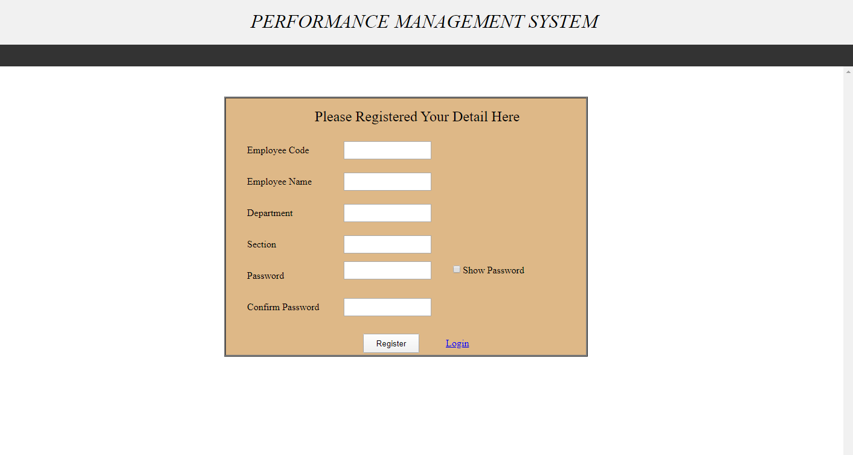

1. **Login Page :**

In login Page registered user can login by their User ID and Password

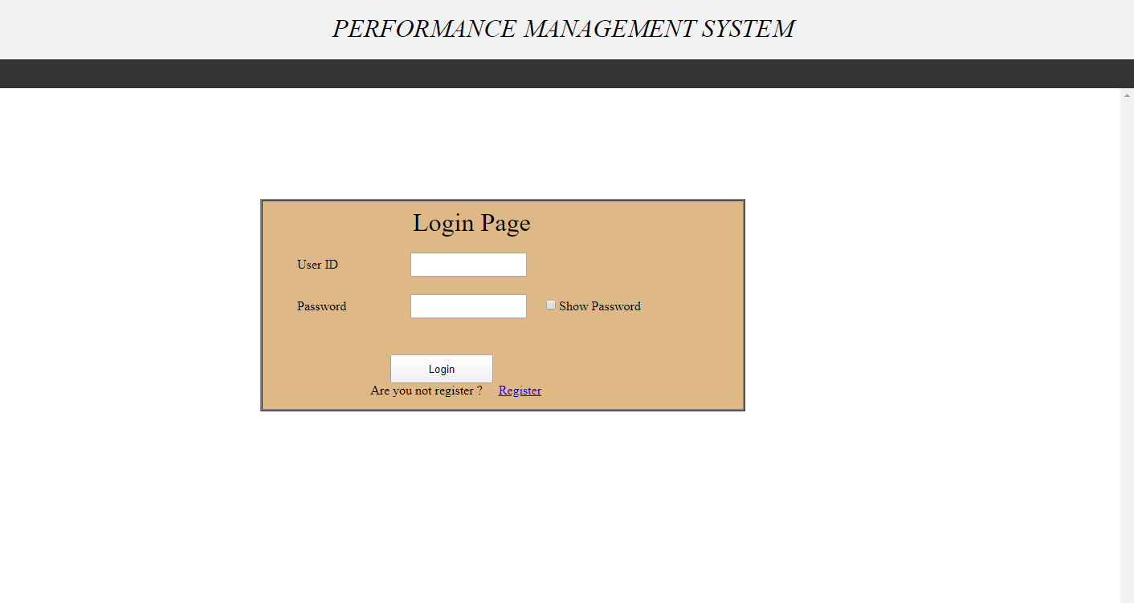

1. **Employee Details Form**

In this form HR Person can upload details of joining of new employee and search details by use of department and section and update and delete employee details

Employee Details are

Employee Name

Employee Code

Designation

Department

Section

DOJ, DOP, DOC, DOE

Qualification

Previous Experience

Reporting Person Name

All the details are fill compulsory

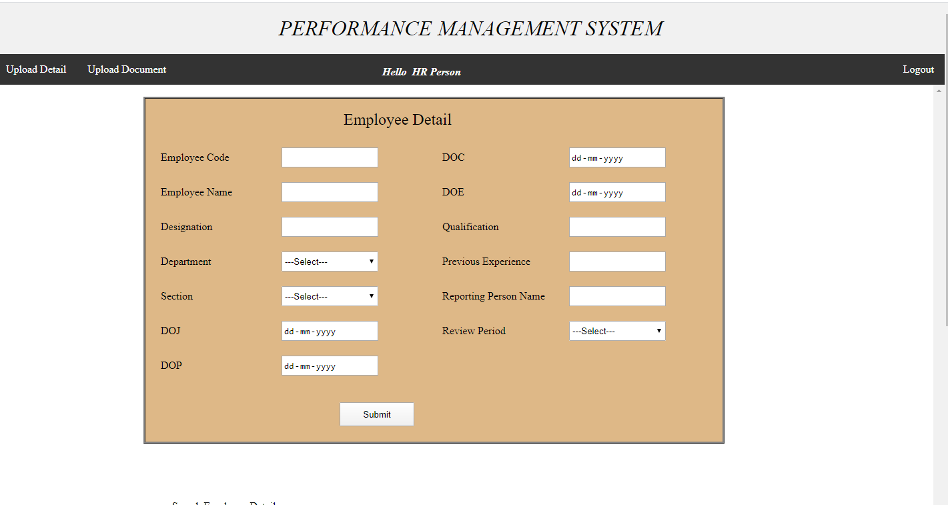

1. Upload Documents Form:

In this form HR can upload Joining Letter, Probation Letter, and Confirm Letter and Extend letter of the employee

Employee name

Employee Code

Upload Document

This field are fill compulsory and HR can delete this document

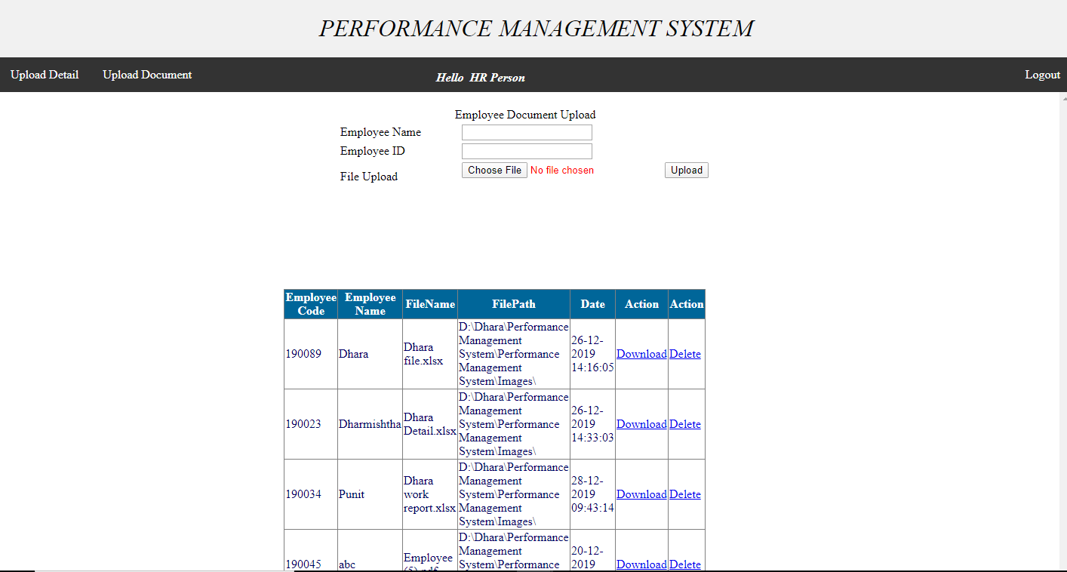

1. **View Details Form:**

In this form employee can view their details

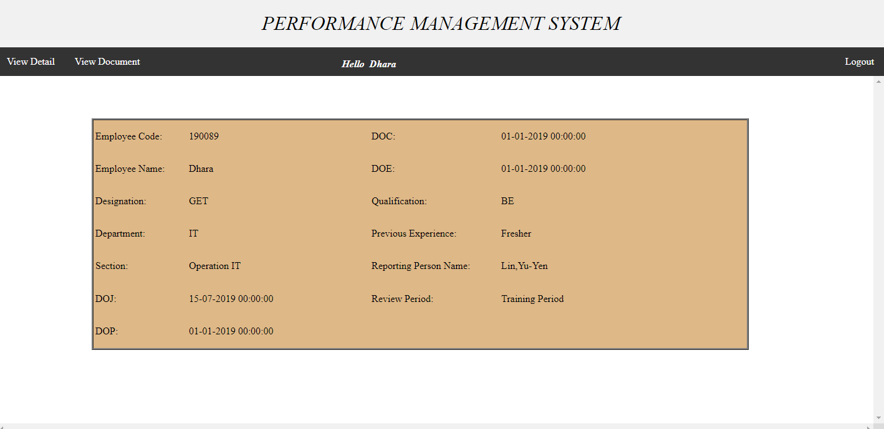

1. **View Document Form:**

In this form employee can view their documents and download

